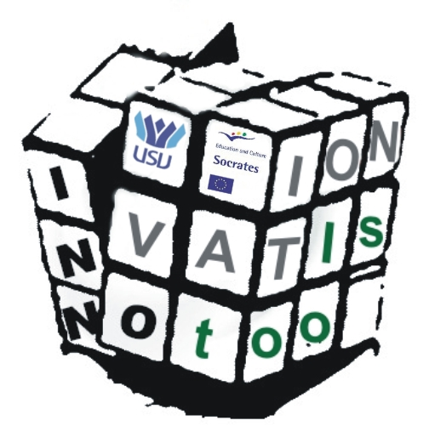


Enterprise level Inno-tools – Innovation tool-box in European peripheral areas
INNO TOOLS

Erasmus IP

Description of Studies
Objectives of the course are:
- to get an overview on innovation research in Europe and best practice cases for innovation for European peripheral areas
- to get familiar with innovation tools and innovation management
- to bring together a broad range of international experts and to learn to work in international group
Contents of the course among other things are:
- What is innovation and why it is important
- Innovation processes in enterprises and other organisations
- Innovation systems and environments, regional innovation strategies
- Tools for innovation process management
- Commercialisation and business management
- Regional information and case studies
- Innovation planning/management process, usage of different tools

Structure

Course content
- Pre studies 4 credits (at home institution)
- Contact course 3 credits (in Suceava / Romania in 7-18 April 2008)
- Post tasks 3 credits (at home institution)

Flow chart

